Step 1: Launch an Instance
You can launch a Linux instance using the AWS Management Console as described in the following procedure. This tutorial is intended to help you launch your first instance quickly, so it doesn't cover all possible options. For more information about the advanced options, see Launching an Instance.
To launch an instance
- Open the Amazon EC2 console at https://console.aws.amazon.com/ec2/.
- From the console dashboard, choose Launch Instance.
- The Choose an Amazon Machine Image (AMI) page displays a list of basic configurations, called Amazon Machine Images (AMIs), that serve as templates for your instance. Select the HVM edition of the Amazon Linux AMI. Notice that this AMI is marked "Free tier eligible."
- On the Choose an Instance Type page, you can select the hardware configuration of your instance. Select the t2.micro type, which is selected by default. Notice that this instance type is eligible for the free tier.
Note
T2 instances, such as t2.micro, must be launched into a VPC. If your AWS account supports EC2-Classic and you do not have a VPC in the selected region, the launch wizard creates a VPC for you and you can continue to the next step. Otherwise, the Review and Launch button is disabled and you must choose Next: Configure Instance Details and follow the directions to select a subnet.
- Choose Review and Launch to let the wizard complete the other configuration settings for you.
- On the Review Instance Launch page, under Security Groups, you'll see that the wizard created and selected a security group for you. You can use this security group, or alternatively you can select the security group that you created when getting set up using the following steps:
  - Choose Edit security groups.
  - On the Configure Security Group page, ensure that Select an existing security group is selected.
  - Select your security group from the list of existing security groups, and then choose Review and Launch.
- On the Review Instance Launch page, choose Launch.
- When prompted for a key pair, select Choose an existing key pair, then select the key pair that you created when getting set up.
Alternatively, you can create a new key pair. Select Create a new key pair, enter a name for the key pair, and then choose Download Key Pair. This is the only chance for you to save the private key file, so be sure to download it. Save the private key file in a safe place. You'll need to provide the name of your key pair when you launch an instance and the corresponding private key each time you connect to the instance.
Caution
Don't select the Proceed without a key pair option. If you launch your instance without a key pair, then you can't connect to it.
When you are ready, select the acknowledgement check box, and then choose Launch Instances.
- A confirmation page lets you know that your instance is launching. Choose View Instances to close the confirmation page and return to the console.
- On the Instances screen, you can view the status of the launch. It takes a short time for an instance to launch. When you launch an instance, its initial state is pending. After the instance starts, its state changes to running and it receives a public DNS name. (If the Public DNS (IPv4) column is hidden, choose the Show/Hide icon in the top right corner of the page and then select Public DNS (IPv4).)
- It can take a few minutes for the instance to be ready so that you can connect to it. Check that your instance has passed its status checks; you can view this information in the Status Checks column.

Open the Amazon EC2 console at https://console.aws.amazon.com/ec2/.
From the console dashboard, choose Launch Instance.

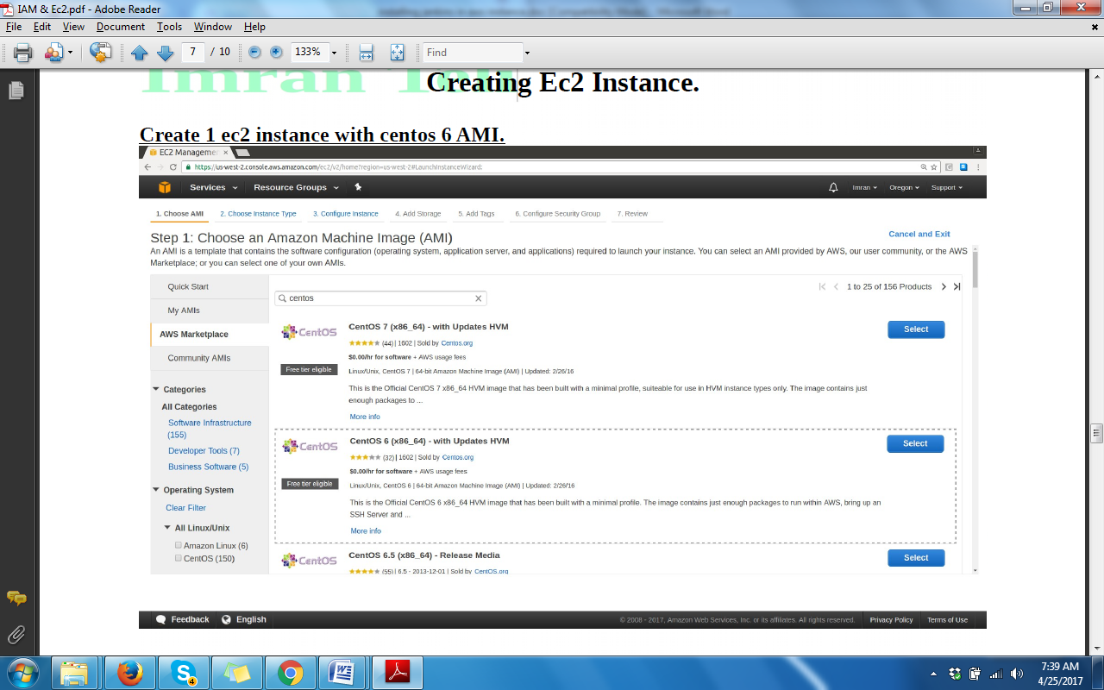

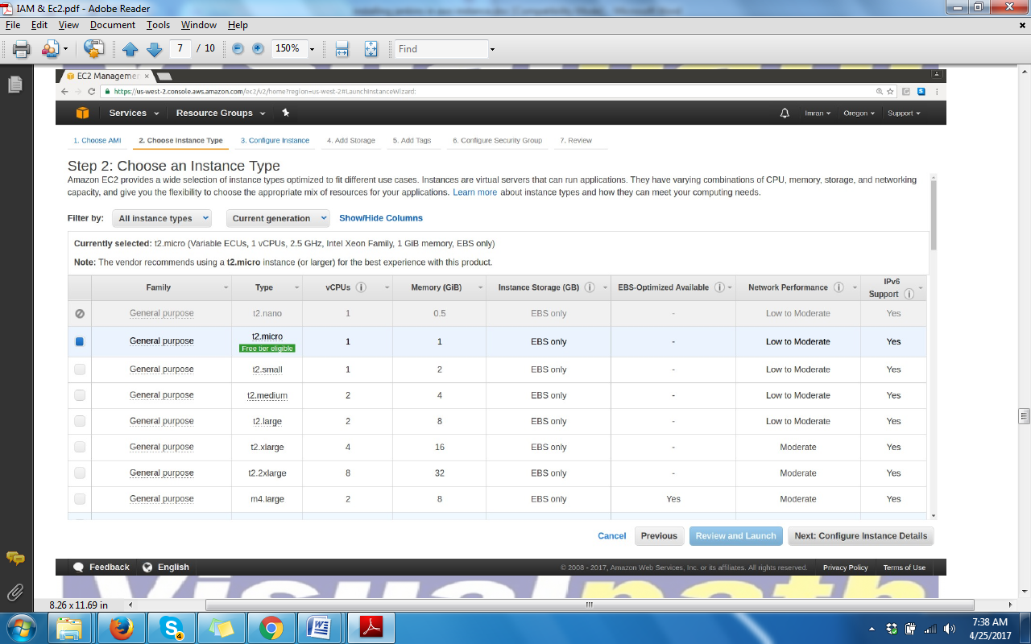
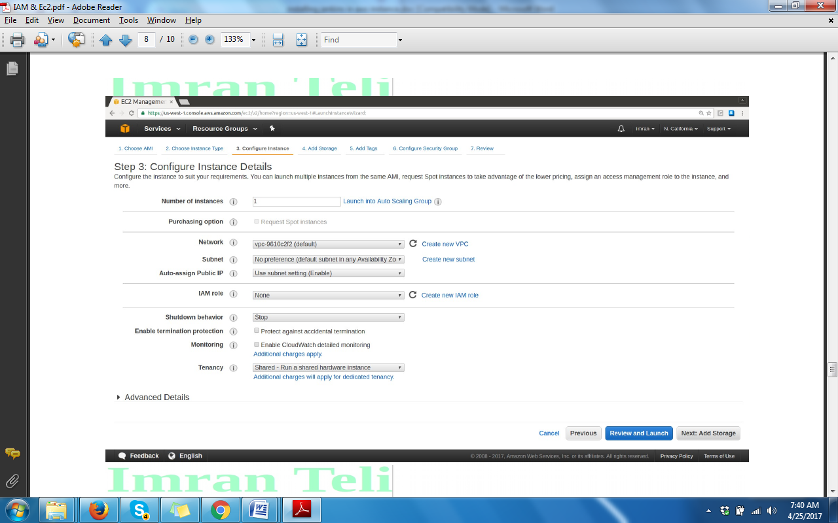
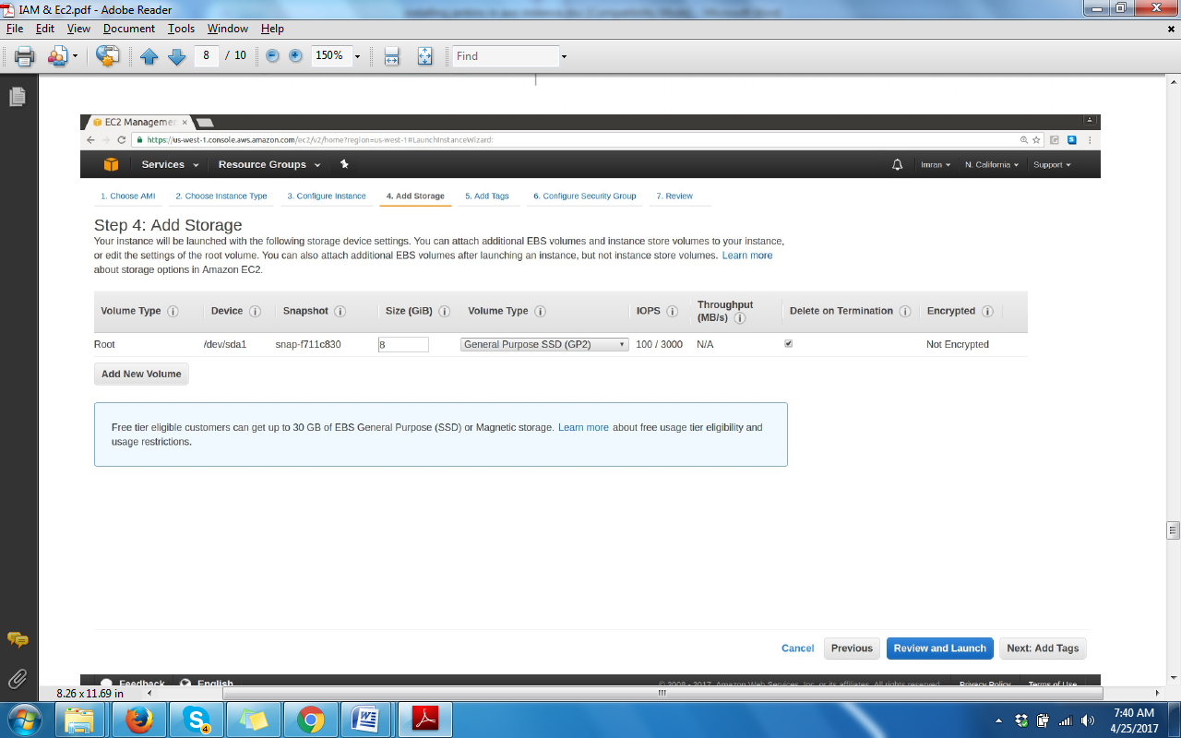

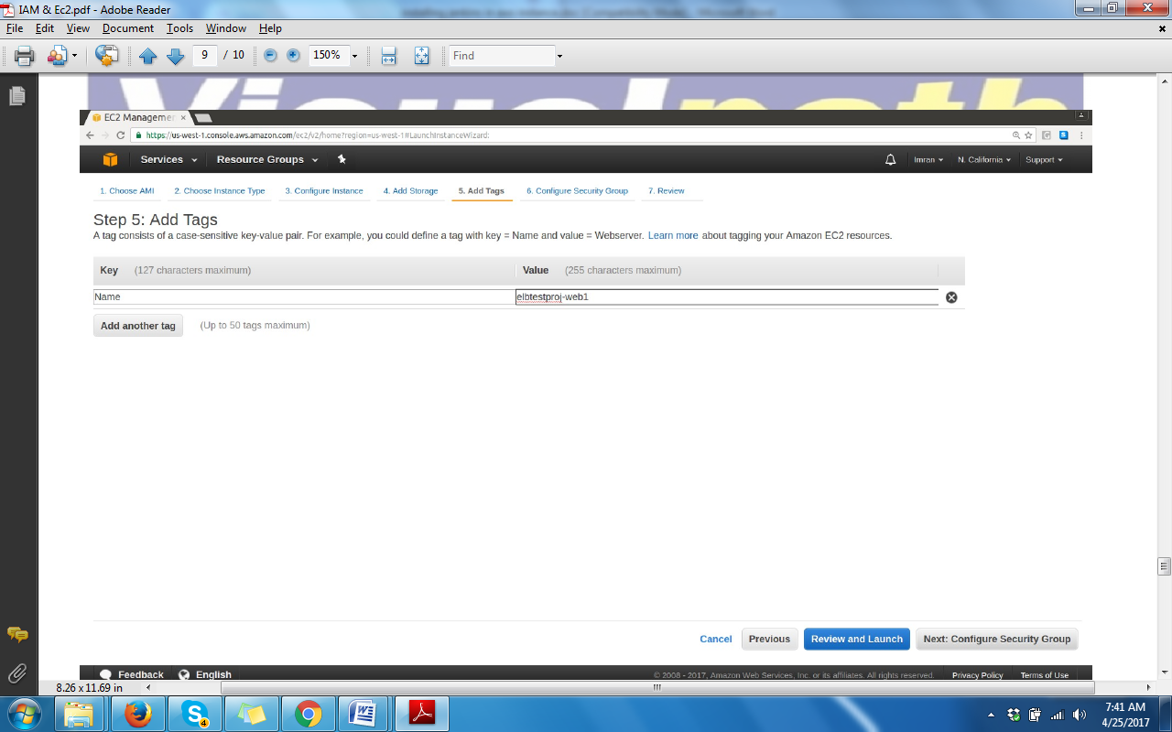
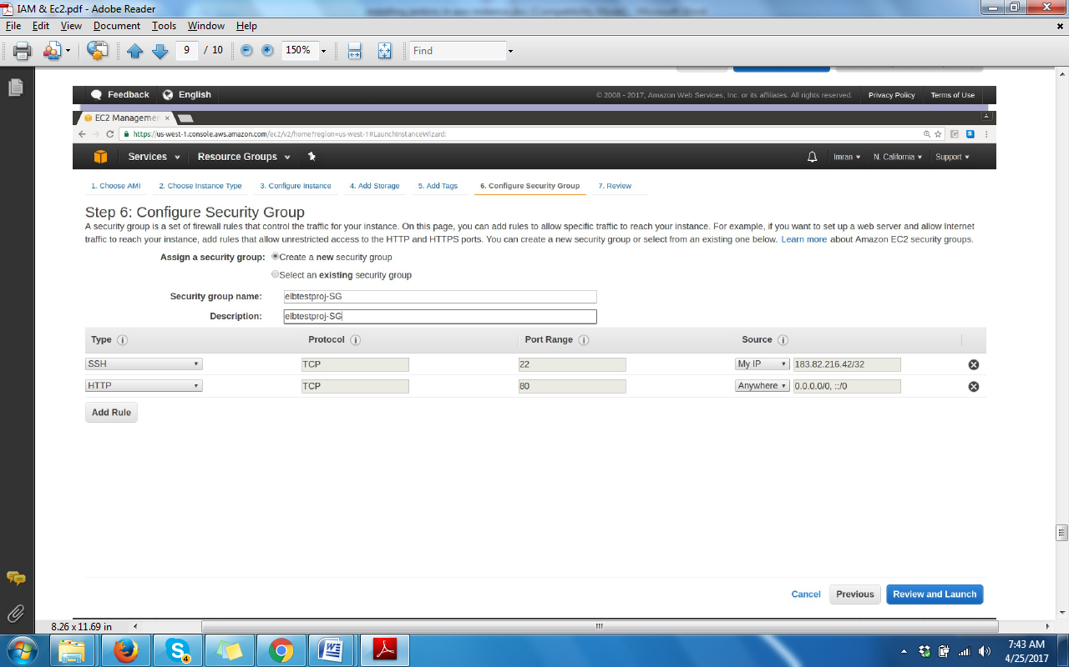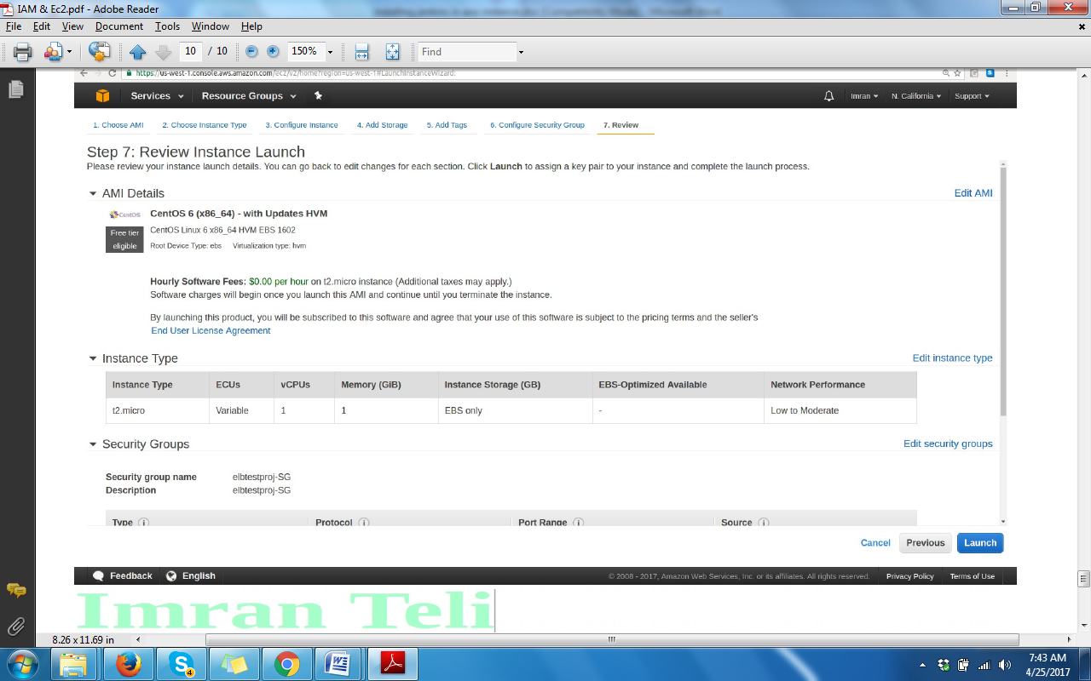
- On the Review Instance Launch page, under Security Groups, you'll see that the wizard created and selected a security group for you. You can use this security group, or alternatively you can select the security group that you created when getting set up using the following steps:
  - Choose Edit security groups.
  - On the Configure Security Group page, ensure that Select an existing security group is selected.
  - Select your security group from the list of existing security groups, and then choose Review and Launch.
- On the Review Instance Launch page, choose Launch.
- When prompted for a key pair, select Choose an existing key pair, then select the key pair that you created when getting set up.
Alternatively, you can create a new key pair. Select Create a new key pair, enter a name for the key pair, and then choose Download Key Pair. This is the only chance for you to save the private key file, so be sure to download it. Save the private key file in a safe place. You'll need to provide the name of your key pair when you launch an instance and the corresponding private key each time you connect to the instance.
Caution
Don't select the Proceed without a key pair option. If you launch your instance without a key pair, then you can't connect to it.
When you are ready, select the acknowledgement check box, and then choose Launch Instances.
- A confirmation page lets you know that your instance is launching. Choose View Instances to close the confirmation page and return to the console.
- On the Instances screen, you can view the status of the launch. It takes a short time for an instance to launch. When you launch an instance, its initial state is pending. After the instance starts, its state changes to running and it receives a public DNS name. (If the Public DNS (IPv4) column is hidden, choose the Show/Hide icon in the top right corner of the page and then select Public DNS (IPv4).)
- It can take a few minutes for the instance to be ready so that you can connect to it. Check that your instance has passed its status checks; you can view this information in the Status Checks column.

Create 3 instances using thw above steps and name them as
1)create first instance as
proj_jenkins(ubuntu
security group (secgrp_ jenkin)
security group rules protocols
ssh 20
http 80
custom tcp 8080
name keypair as (seckey_jenkin),save the key in a superate directory
--save and lauch instance
Create oracle account for java

Goto terminal
Goto the path of the keypair you have saved(Ex: /home/devops/keys/)
Then change the permissions of the keypair
$chmod 400 keypairname
$shh –i keypairname ubuntu@ipof the instance
Then enter
-then we will enter into ubuntu
-go to root user and install all the software related Jenkins as follows
-install jekins in a sequence mentions below
>Open open Jdk
sudo add-apt-repository ppa:openjdk-r/ppa
sudo apt-get update
sudo apt-get install openjdk-7-jdk

>Jenkins
wget -q -O - https://pkg.jenkins.io/debian/jenkins-ci.org.key | sudo apt-key add -
sudo sh -c 'echo deb http://pkg.jenkins.io/debian-stable binary/ > /etc/apt/sources.list.d/jenkins.list'
sudo apt-get update
sudo apt-get install jenkins

>Maven
sudo apt-get update
sudo apt-get install maven

>Iptables off

2)proj_tomcat
Login as root user
sudo -i
#apt-get update
# apt-get install default-jre
# apt-get install zip
# wget http://www-eu.apache.org/dist/tomcat/tomcat-8/v8.5.14/bin/apache-tomcat-8.5.14.zip
# mv apache-tomcat-8.5.14.zip /opt
# cd /opt
# unzip apache-tomcat-8.5.14.zip
# cd apache-tomcat-8.5.14
Give tomcat start & stop script executable permission
# cd /opt/apache-tomcat-8.5.14/bin
# chmod u+x startup.sh
# chmod u+x shutdown.sh
# chmod u+x catalina.sh
Open browser and verify tomcat service
http://tomcatIP:8080
Set user, password & role for tomcat server.
# cd /opt/apache-tomcat-8.5.14/
# vi conf/tomcat-users.xml
Replace below mentioned content
-->
<!--
<role rolename="tomcat"/>
<role rolename="role1"/>
<user username="tomcat" password="<must-be-changed>" roles="tomcat"/>
<user username="both" password="<must-be-changed>" roles="tomcat,role1"/>
<user username="role1" password="<must-be-changed>" roles="role1"/>
-->
</tomcat-users>
with
-->
<role rolename="manager-script"/>
<role rolename="manager-gui"/>
<user username="tomcat" password="tomcat" roles="manager-script,manager-gui"/>
</tomcat-users>

Visualpath
Imran Teli

Comment antiResourceLocking values.
# vi webapps/manager/META-INF/context.xml
Replace
<Context antiResourceLocking="false" privileged="true" >
<Valve className="org.apache.catalina.valves.RemoteAddrValve"
allow="127\.\d+\.\d+\.\d+|::1|0:0:0:0:0:0:0:1" />
</Context>
with
<Context antiResourceLocking="false" privileged="true" >
<!--
<Valve className="org.apache.catalina.valves.RemoteAddrValve"
allow="127\.\d+\.\d+\.\d+|::1|0:0:0:0:0:0:0:1" />
-->
</Context>
Stop and start tomcat.
# bin/shutdown.sh
# bin/startup.sh
Verify the settings
http://tomcatIP: 8080/manager/
Username: tomcat
password: tomcat
You should see below mentioned screen
3)proj_nexus

Jenkins Plugin Setup
Install plugins:- git, zentimestamp & nexus.​

​​Access Jenkins server from browser
http://
​<jenkinsIP>​
:8080

Create new build job
New item --> Enter project name --> Select freestyle project
Select git --> Enter GameOfLife git project URL (https://github.com/wakaleo/ga)
Add Build step --> Invoke top level maven project --> In Goals enter "install"
Save --> Build Now.

Build verification.
In your project's dashboard --> Go to the workspace -->
gameoflife-web --> target
You should see gameoflife.war.

​Nexus Setup

Nexus server on Centos.
· Nexus installation steps below.
· Create a centos vagrant vm
​/Ec2​
and login into it
​(ssh)
.
​ ​
$ sudo -i
# yum install -y java-1.8.0-openjdk.x86_64 vim wget
# export RUN_AS_USER=root
# wget http://www.sonatype.org/downlo
# sudo cp nexus-latest-bundle.tar.gz /usr/local/
# cd /usr/local
# sudo tar xvzf nexus-latest-bundle.tar.gz
# sudo ln -s nexus-2.13.0-01 nexus
# /usr/local/nexus/bin/nexus start​

From browser hit URL <Nexus server IP>:8081/nexus.
Click login button and enter the credentials. (admin/admin123)
Create hosted repository named “gameoflife” with all default settings.​

​Configure nexus plugin to push the artifact to nexus repo.​

​​

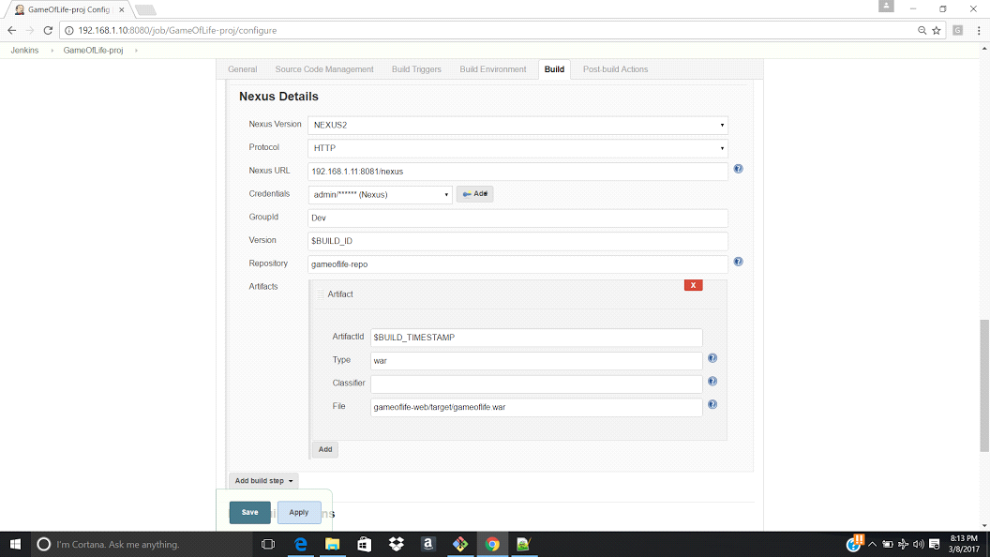

FOLLOW THIS LINK
https://wiki.jenkins-ci.org/display/JENKINS/Installing+Jenkins+on+Ubuntu
also install, wget,java,

swithch of f firwall---→ service iptables stop (start,status)
install java

